Assignment 2
1.Encapsulation + Getter/Setter
WAP in Java
Create a class named Employee with private instance variables empId, empName, and salary.
Provide public getters and setters for all variables.
Create a method displayDetails() to print employee details.
Create an object in the main method and assign values using setters then display them.
Program:
class Employee
{
private int empId;
private String empName;
private double salary;

public int getEmpId() {
return empId;
}
public void setEmpId(int empId) {
this.empId = empId;
}
public String getEmpName() {
return empName;
}

public void setEmpName(String empName) {
this.empName = empName;
}

public double getSalary() {
return salary;
}

public void setSalary(double salary) {
this.salary = salary;
}

public void displayDetails() {
System.out.println("Employee ID: " + empId);
System.out.println("Employee Name: " + empName);
System.out.println("Salary: " + salary);
}
}
public class EmoloyeeDetails {

public static void main(String[] args) {
Employee emp = new Employee();
emp.setEmpId(101);
emp.setEmpName("John");
emp.setSalary(50000.0);
emp.displayDetails()
}
}

Output:
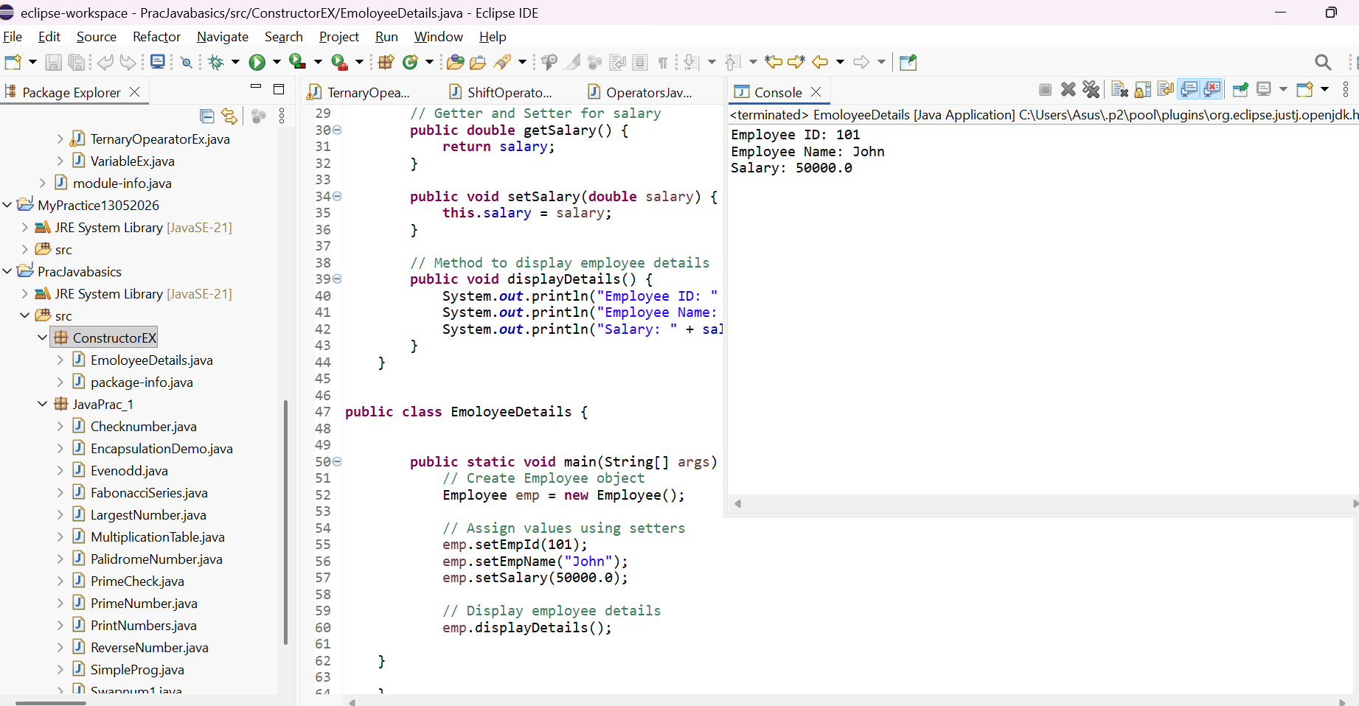

Employee ID: 101
Employee Name: John
Salary: 50000.0

2. Inheritance + Method Overriding
Create a base class Vehicle with a method fuelType() which prints "Runs on fuel".
Create a child class ElectricCar and override the fuelType() method to print "Runs on electricity".
Create objects of both classes and call their respective methods.
Program:
class Vehicle {
public void fuelType() {
System.out.println("Runs on fuel");
}
}
class ElectricCar extends Vehicle {
public void fuelType() {
System.out.println("Runs on electricity");
}
}
public class VehicleDemo {
public static void main(String[] args) {
Vehicle v = new Vehicle();
v.fuelType();
ElectricCar e = new ElectricCar();
e.fuelType();
}
}
Screenshot:
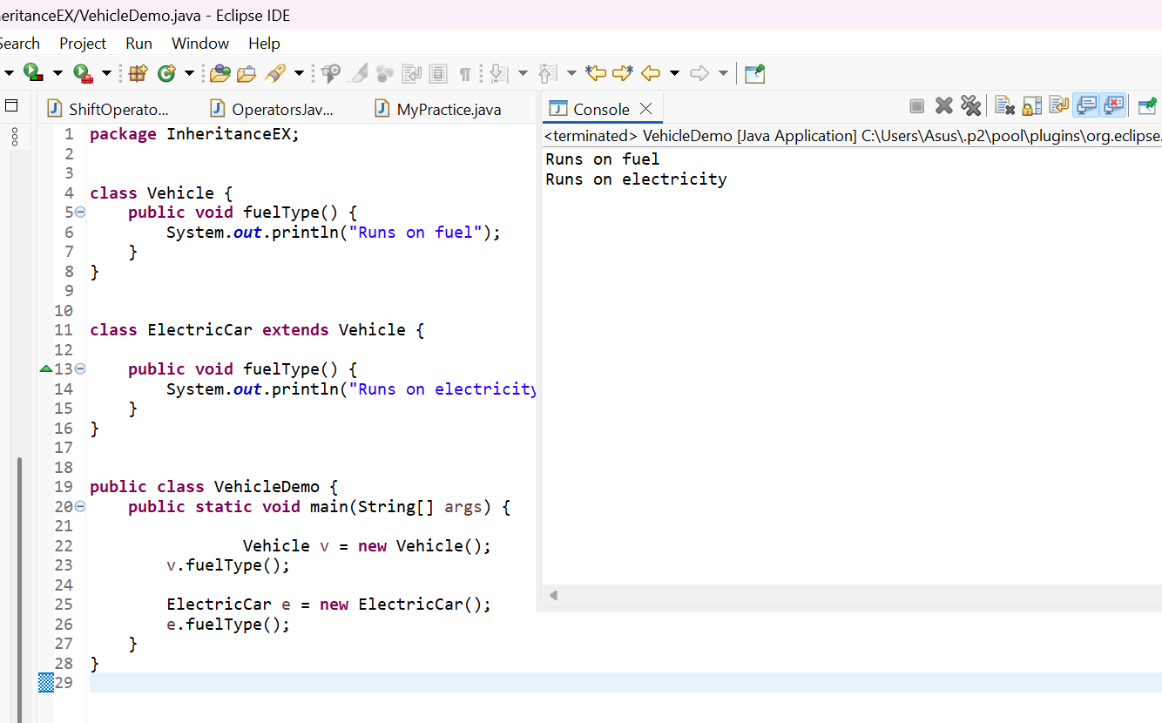
Output:
Runs on fuel
Runs on electricity

3. Constructor Overloading
Create a class Product having instance variables productId, productName, and price.
Implement:
A default constructor that prints "Product Created".
A parameterized constructor that initializes the product details.
Write a method display Product() to print product details.
Create both types of objects in the main method.
Program:
class Product {

int productId;
String productName;
double price;

Product() {
System.out.println("Product Created");
}

Product(int productId, String productName, double price) {
this.productId = productId;
this.productName = productName;
this.price = price;
}

void displayProduct() {
System.out.println("Product ID: " + productId);
System.out.println("Product Name: " + productName);
System.out.println("Price: " + price);
}
}
public class ProductDemo {
public static void main(String[] args) {
Product p1 = new Product();
Product p2 = new Product(101, "Laptop", 55000.0);
p2.displayProduct();
}
}

Screenshot:
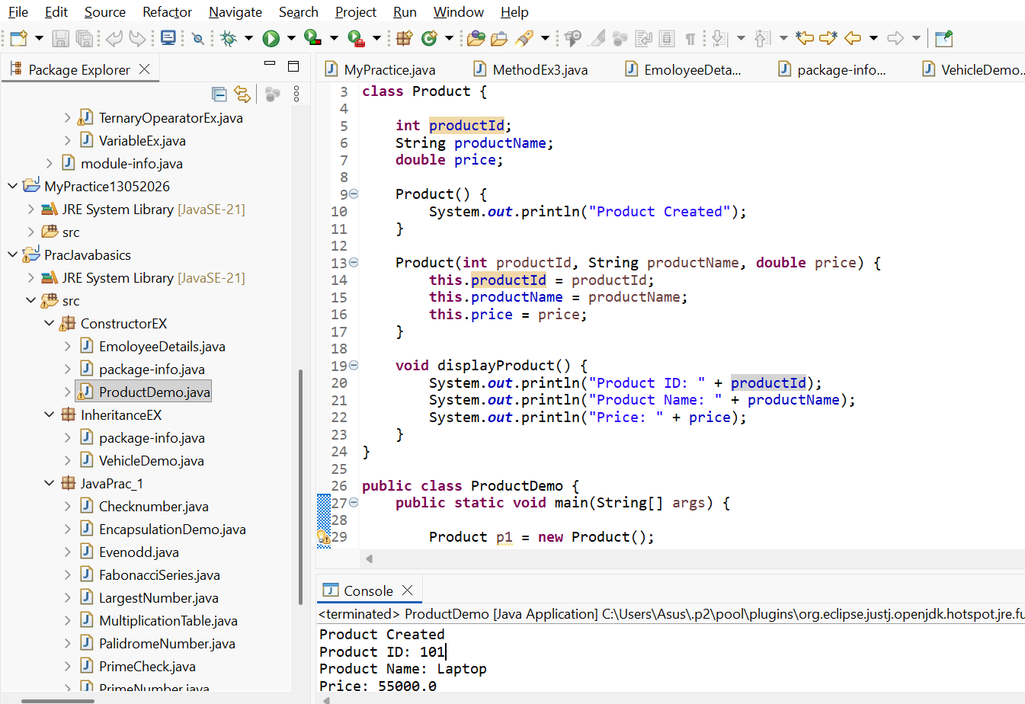

Output:
Product Created
Product ID: 101
Product Name: Laptop
Price: 55000.0

4. Method Overloading
Create a class Calculator with overloaded methods add():
add(int a, int b)
add(double a, double b)
Call both methods inside the main method and print results.

Program:
class Calculator {
int add(int a, int b) {
return a + b;
}
double add(double a, double b) {
return a + b;
}
}
public class MethodOverloadingDemo {
public static void main(String[] args) {
Calculator calc = new Calculator();
System.out.println("Sum of Integers: " + calc.add(10, 20));
System.out.println("Sum of Doubles: " + calc.add(10.5, 20.5));
}}
Screenshot:
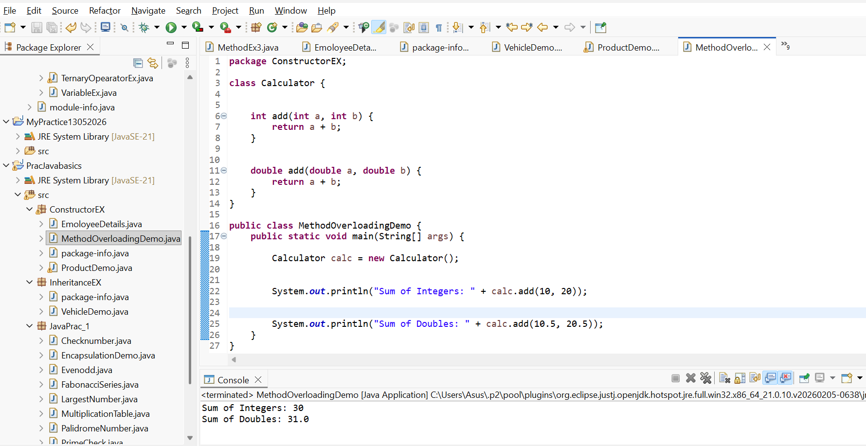
Output:
Sum of Integers: 30
Sum of Doubles: 31.0

5. Abstraction using Abstract Class
Create an abstract class Animal with an abstract method sound().
Create two subclasses Dog and Cat and provide implementation for sound() method.
Create objects and call sound() for each.
abstract class Animal {
Program:
package InheritanceEX;
abstract class Animal
{
abstract void sound();
}
class Dog extends Animal {
void sound() {
System.out.println("Dog barks"); }
}class Cat extends Animal {
void sound() {
System.out.println("Cat meows");
}}
public class AbstractDemo {
public static void main(String[] args) {
Dog dog = new Dog();
Cat cat = new Cat();
dog.sound();
cat.sound();
}}

Screenshot:

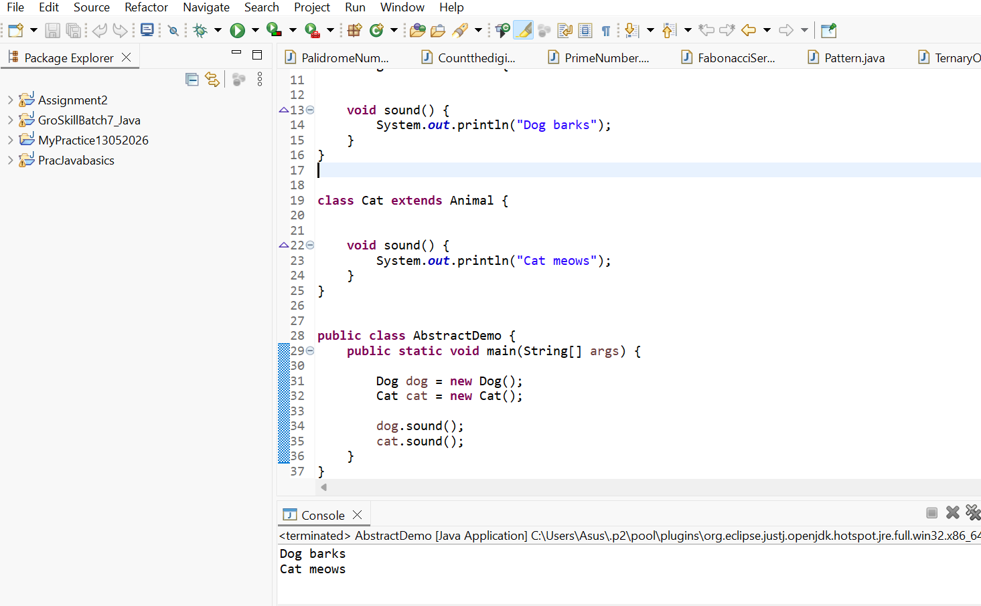

Output:
Dog barks
Cat meows

6. Interface Implementation
Create an interface Payment with a method makePayment().
Create two classes UPI and CreditCard implementing this interface and define their own payment messages.
Call the method through interface reference.
Program:
package InterfaceEX;
interface Payment {
void makePayment();
}
class UPI implements Payment {
public void makePayment() {
System.out.println("Payment made using UPI");
}
}
class CreditCard implements Payment {
public void makePayment() {
System.out.println("Payment made using Credit Card");
}
}

public class InterfaceDemo {
public static void main(String[] args) {

Payment p1 = new UPI();
p1.makePayment();
Payment p2 = new CreditCard();
p2.makePayment();
}
}

Screenshot:
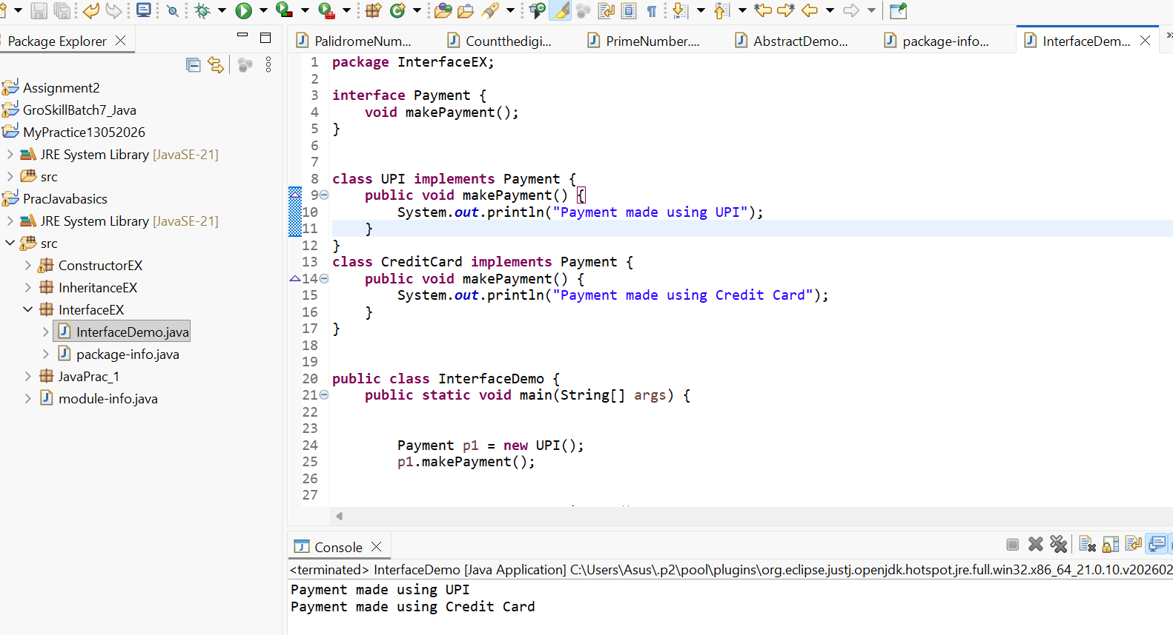

Output:
Payment made using UPI
Payment made using Credit Card

7. Use of super keyword
Create a class Person with a constructor that prints "Person Created".
Create a subclass Student that calls the parent constructor using super() and prints "Student Created".
Create an object and observe the order of execution.

Program:
package ConstructorEX;
class Person {
Person() {
System.out.println("Person Created");
}}
class Student extends Person {
Student() { super(); System.out.println("Student Created");
}}
public class SuperDemo {
public static void main(String[] args) {
Student s = new Student();}}
Screenshot: 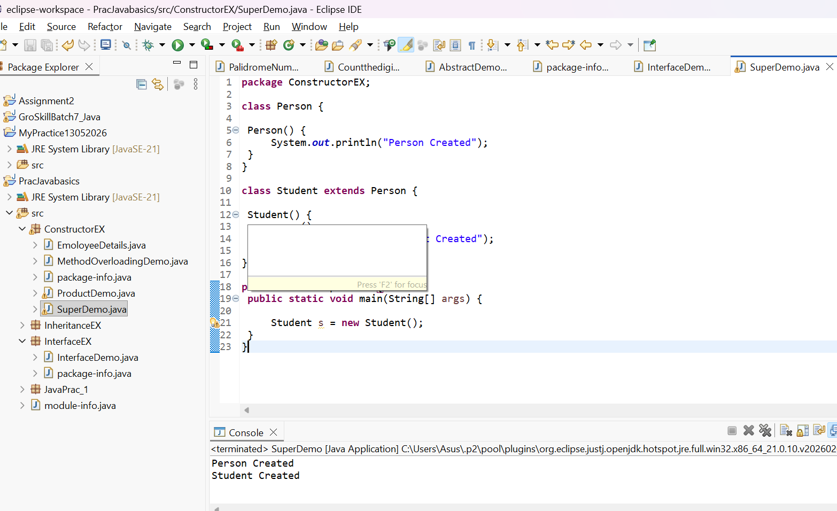

Output:
Person Created
Student Created

8. Polymorphism (Dynamic Binding)
Create a parent class Shape with a method area().
Create subclasses Rectangle and Circle and override the area() method.
Create a reference of Shape and assign objects of both subclasses one by one, calling area() each time.
Program:
package InheritanceEX;

class Shape {
void area() {
System.out.println("Calculating Area");
}
}
class Rectangle extends Shape {
void area() {
int length = 10;
int width = 5;
System.out.println("Area of Rectangle = " + (length * width));
}
}
class Circle extends Shape {
void area() {
double radius = 7;
System.out.println("Area of Circle = " + (3.14 * radius * radius));
}
}

public class DynamicBindingDemo {
public static void main(String[] args) {
Shape s;
s = new Rectangle();
s.area();
s = new Circle();
s.area();
}
}

Screenshot:
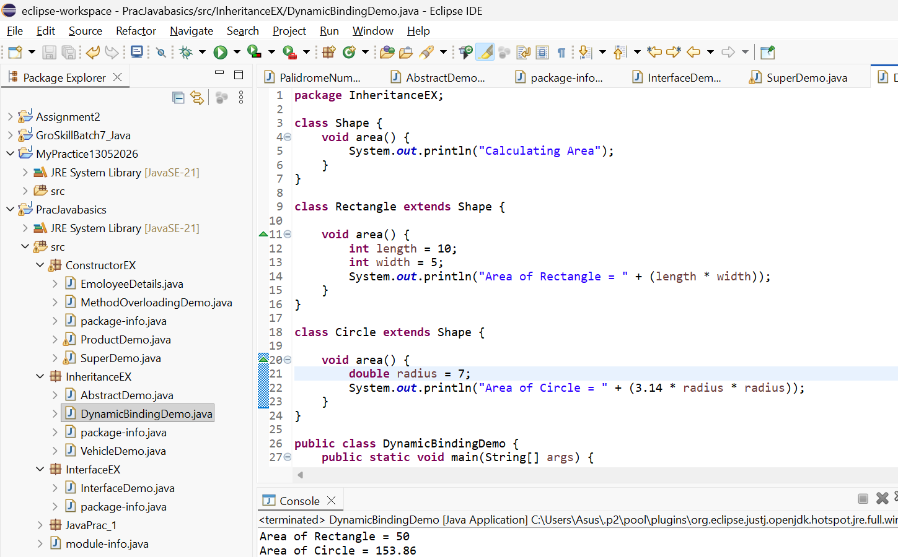
Output:
Area of Rectangle = 50
Area of Circle = 153.86

9. Final Keyword
Create a class Bank with a final variable IFSC and final method showIFSC().
Try creating a subclass HDFCBank and attempt overriding the final method (should show compile-time restriction).
Create a main method to demonstrate usage.
Program:
package InheritanceEX;

class Bank {
final String IFSC = "HDFC0001234";
final void showIFSC() {
System.out.println("IFSC Code: " + IFSC);
}
}
class HDFCBank extends Bank
{
}
public class FinalKeywordDemo {
public static void main(String[] args)
{
HDFCBank bank = new HDFCBank();
bank.showIFSC();
}
}
Screenshot:
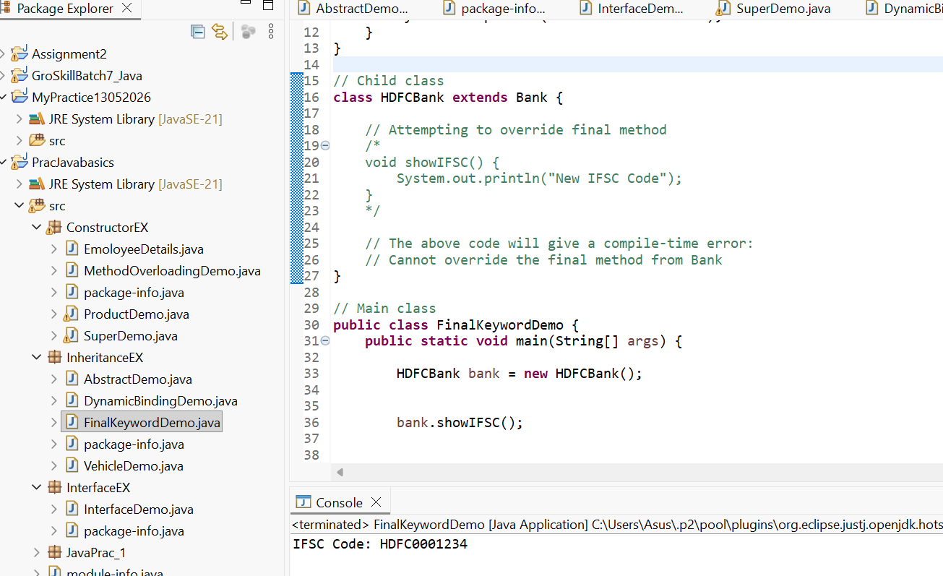

Output:
IFSC Code: HDFC0001234

package InheritanceEX;
class Bank {
final String IFSC = "HDFC0001234";
final void showIFSC() {
System.out.println("IFSC Code: " + IFSC);
}
}
class HDFCBank extends Bank
{
void showIFSC() {
System.out.println("New IFSC Code");
}}
public class FinalKeywordDemo {
public static void main(String[] args) {
HDFCBank bank = new HDFCBank();
bank.showIFSC(); }}

Screenshot:
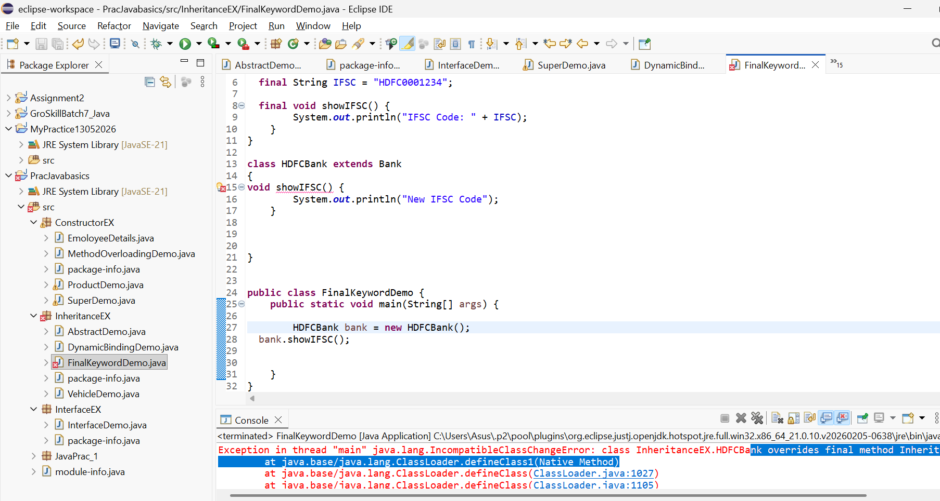

The about Screenshot shows the compile time error.
final variable (IFSC): Once assigned, its value cannot be changed.
final method (showIFSC()): Cannot be overridden in a child class.
The HDFCBank class inherits from Bank but cannot override the showIFSC() method because it is declared as final.
The final keyword is used to restrict modification. A final variable acts like a constant, and a final method cannot be overridden by subclasses. This helps ensure that critical data and behaviour remain unchanged."

10. Static Keyword
Create a class Student having static variable collegeName and instance variables name and rollNo.
Write a method to print both static and instance data.
Create multiple objects to show static value remains constant.

Program:
package ConstructorEX;
class Student
{

static String collegeName = "ABC College";
String name;
int rollNo;

Student(String name, int rollNo) {
this.name = name;
this.rollNo = rollNo;
}
void display() {
System.out.println("Name: " + name);
System.out.println("Roll No: " + rollNo);
System.out.println("College Name: " + collegeName);
System.out.println();
}
}

public class StudentDemo {
public static void main(String[] args) {
Student s1 = new Student("Rahul", 101);
Student s2 = new Student("Priya", 102);
Student s3 = new Student("Amit", 103);
s1.display();
s2.display();
s3.display();
}}
Screenshot:
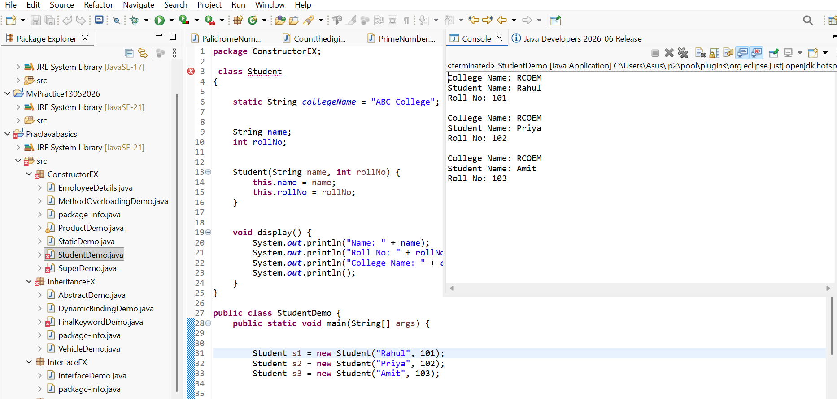

Output:
College Name: RCOEM
Student Name: Rahul
Roll No: 101

College Name: RCOEM
Student Name: Priya
Roll No: 102

College Name: RCOEM
Student Name: Amit
Roll No: 103

11. Class + Object + Method
Create a class Library with an instance variable libraryName.
Create a default constructor to print "Welcome to the Library!".
Create a method showLocation() which prints "This library is located in Mumbai".
Create an object in main() and call both.

Program:
package ConstructorEX;
class Library {
String libraryName;
Library() {
System.out.println("Welcome to the Library!");
} void showLocation() {
System.out.println("This library is located in Mumbai");
} public static void main(String[] args) {
Library lib = new Library();
lib.showLocation() }}
Screenshot:
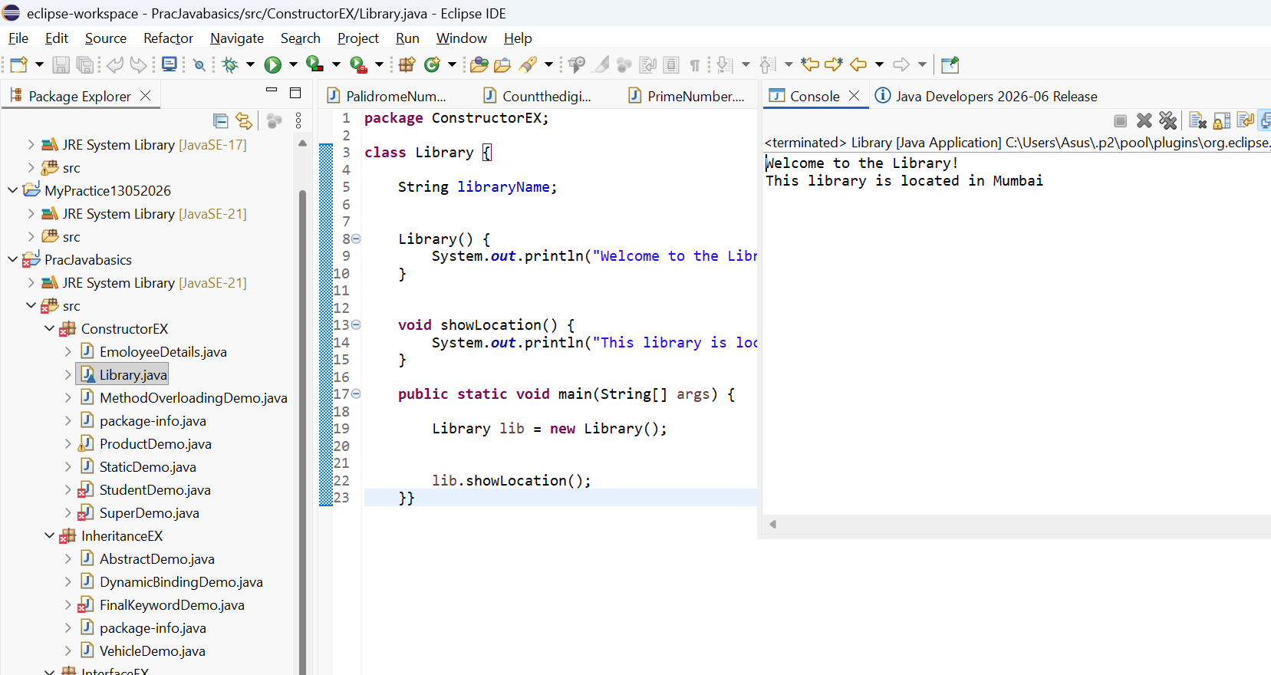
Output:
Welcome to the Library!
This library is located in Mumbai

12. Encapsulation + Validation Logic
Create a class Account with private variables accountHolderName and balance.
Provide setters and getters, where:
setBalance() should not accept negative values (print a warning).
Create an object and update values through setters only.
Program:
package EncapsulationEX;

class Account {
private String accountHolderName;
private double balance;
public void setAccountHolderName(String accountHolderName) {
this.accountHolderName = accountHolderName;
}

// Getter for accountHolderName
public String getAccountHolderName() {
return accountHolderName;
}

// Setter for balance
public void setBalance(double balance) {
if (balance < 0) {
System.out.println("Warning: Balance cannot be negative.");
} else {
this.balance = balance;
}
}

// Getter for balance
public double getBalance() {
return balance;
}
public static void main(String[] args) {
// Create object
Account acc = new Account();

// Update values using setters
acc.setAccountHolderName("Rahul Sharma");
acc.setBalance(5000);

// Display values using getters
System.out.println("Account Holder Name: " + acc.getAccountHolderName());
System.out.println("Balance: " + acc.getBalance());

// Try setting a negative balance
acc.setBalance(-1000);
}
}

Screenshot:

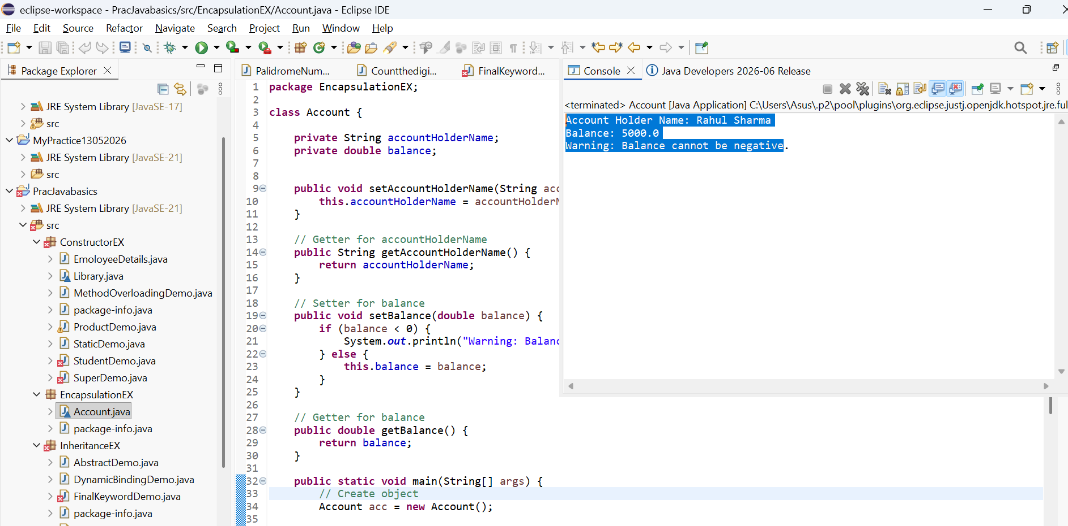
Output:
Account Holder Name: Rahul Sharma
Balance: 5000.0
Warning: Balance cannot be negative

13. Inheritance (Multilevel)
Create three classes:
Device â†’ method start()
Mobile extends Device â†’ method calling()
SmartPhone extends Mobile â†’ method internet()
Create object of SmartPhone and call all methods.
Program:
package InheritanceEX;
class Device {
void start() {
System.out.println("Device is starting...");
]]
class Mobile extends Device {
void calling() {
System.out.println("Calling feature is available.");
}
}class SmartPhone extends Mobile {
void internet() {
System.out.println("Internet feature is available.");
} public static void main(String[] args) {

SmartPhone phone = new SmartPhone();
phone.start();
phone.calling();
phone.internet();
}
}
Screenshot:
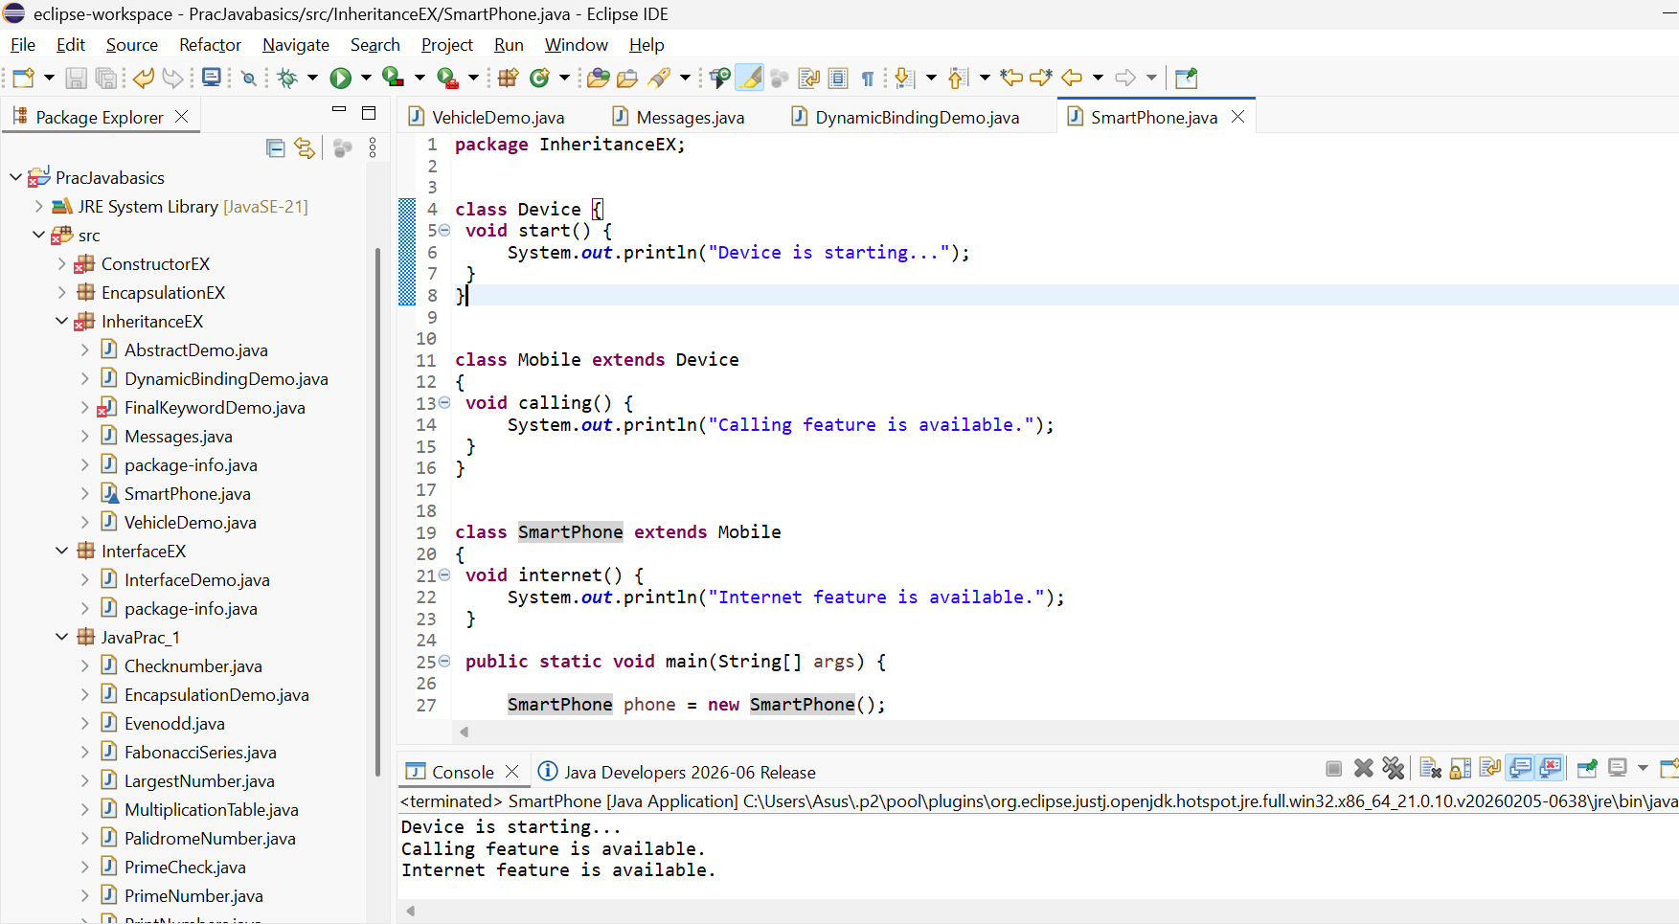

Output:
Device is starting...
Calling feature is available.
Internet feature is available.

14. Hierarchical Inheritance

Create a class Course with a method courseInfo().
Create subclasses Science, Commerce, and Arts each with their own method.
Create objects of each and call methods to show hierarchy.
Program:
package InheritanceEX;
// Parent class
class Course {
void courseInfo() {
System.out.println("This is a course.");
}
}

class Science extends Course {
void scienceSubjects() {
System.out.println("Science subjects: Physics, Chemistry, Biology");
}
}

class Commerce extends Course {
void commerceSubjects() {
System.out.println("Commerce subjects: Accounts, Economics, Business Studies");
}
}

class Arts extends Course {
void artsSubjects() {
System.out.println("Arts subjects: History, Geography, Political Science");
}
}
public class Main {
public static void main(String[] args) {
Science s = new Science();
Commerce c = new Commerce();
Arts a = new Arts();
System.out.println("Science Course:");
s.courseInfo();
s.scienceSubjects();

System.out.println();
System.out.println("Commerce Course:");
c.courseInfo();
c.commerceSubjects();
System.out.println();
System.out.println("Arts Course:");
a.courseInfo();
a.artsSubjects();
}
}
Screenshot:
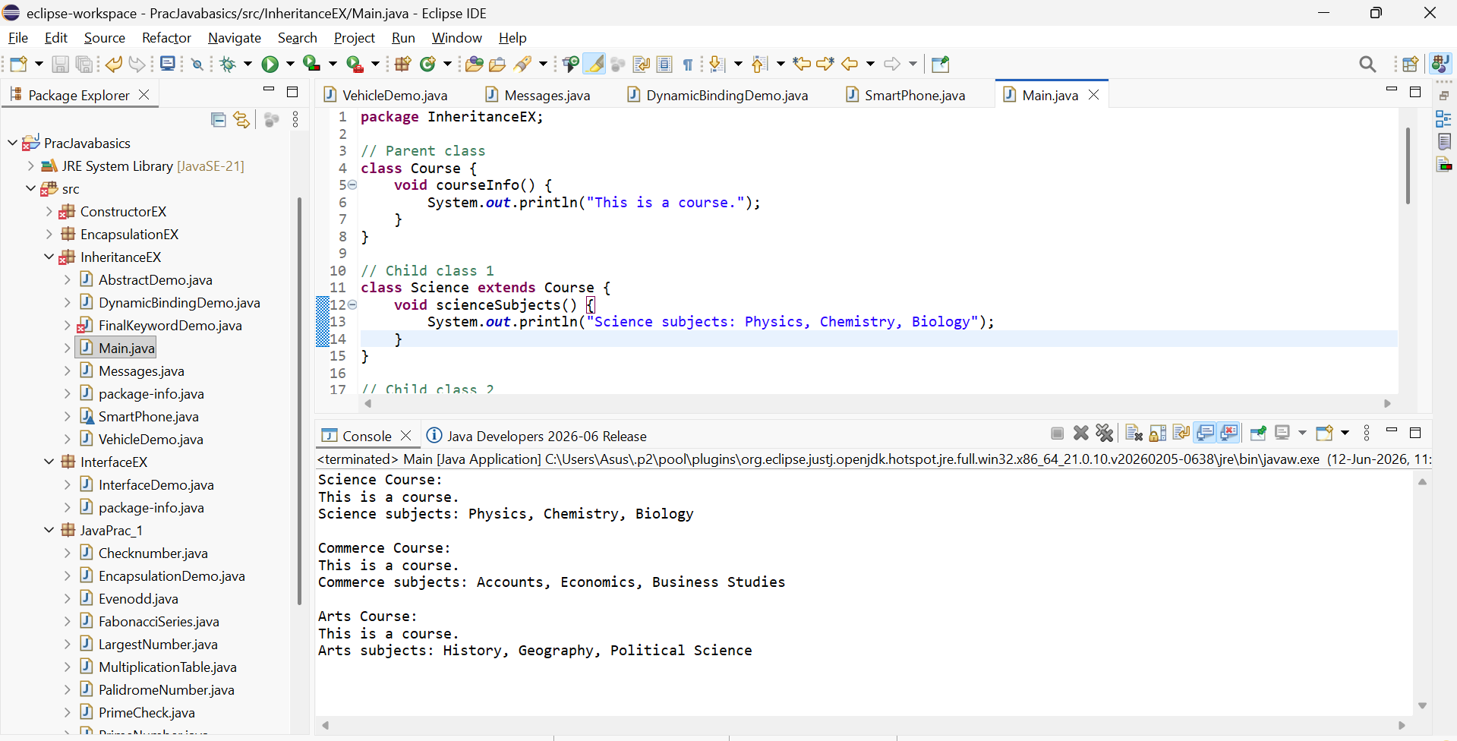
Output:
Science Course:
This is a course.
Science subjects: Physics, Chemistry, Biology

Commerce Course:
This is a course.
Commerce subjects: Accounts, Economics, Business Studies

Arts Course:
This is a course.
Arts subjects: History, Geography, Political Science

15. Method Overloading (Bank Scenario)
Create a class LoanCalculator with two overloaded methods: calculateLoan(int amount)calculateLoan(int amount, double interestRate)Print loan details accordingly. Call both methods from main.

Program:
class LoanCalculator {
void calculateLoan(int amount) {
System.out.println("Loan Amount: ₹" + amount);
System.out.println("Interest Rate: Default Rate");}
void calculateLoan(int amount, double interestRate) {
System.out.println("Loan Amount: ₹" + amount);
System.out.println("Interest Rate: " + interestRate + "%");}
public static void main(String[] args) {
LoanCalculator loan = new LoanCalculator();
loan.calculateLoan(80000);
System.out.println();
loan.calculateLoan(80000, 7.5);}}

Screenshot:
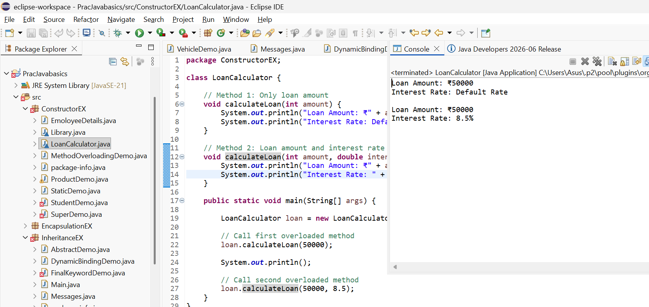

Output:
Loan Amount: ₹80000
Interest Rate: Default Rate
Loan Amount: ₹80000
Interest Rate: 7.5%

16. Method Overriding with super
Create a base class Hospital with a method emergencyService().
Create a subclass CityHospital that overrides the method and calls parent method using super.emergencyService().
Demonstrate overriding in main.

Program:
package ConstructorEX;
class Hospital {
void emergencyService() {
System.out.println("Hospital provides emergency services.");
}
}
class CityHospital extends Hospital {
void emergencyService() {
super.emergencyService(); // Call parent class method
System.out.println("CityHospital provides 24/7 emergency services.");
}
public static void main(String[] args) {
CityHospital ch = new CityHospital();
ch.emergencyService();
}
}
Screenshot:
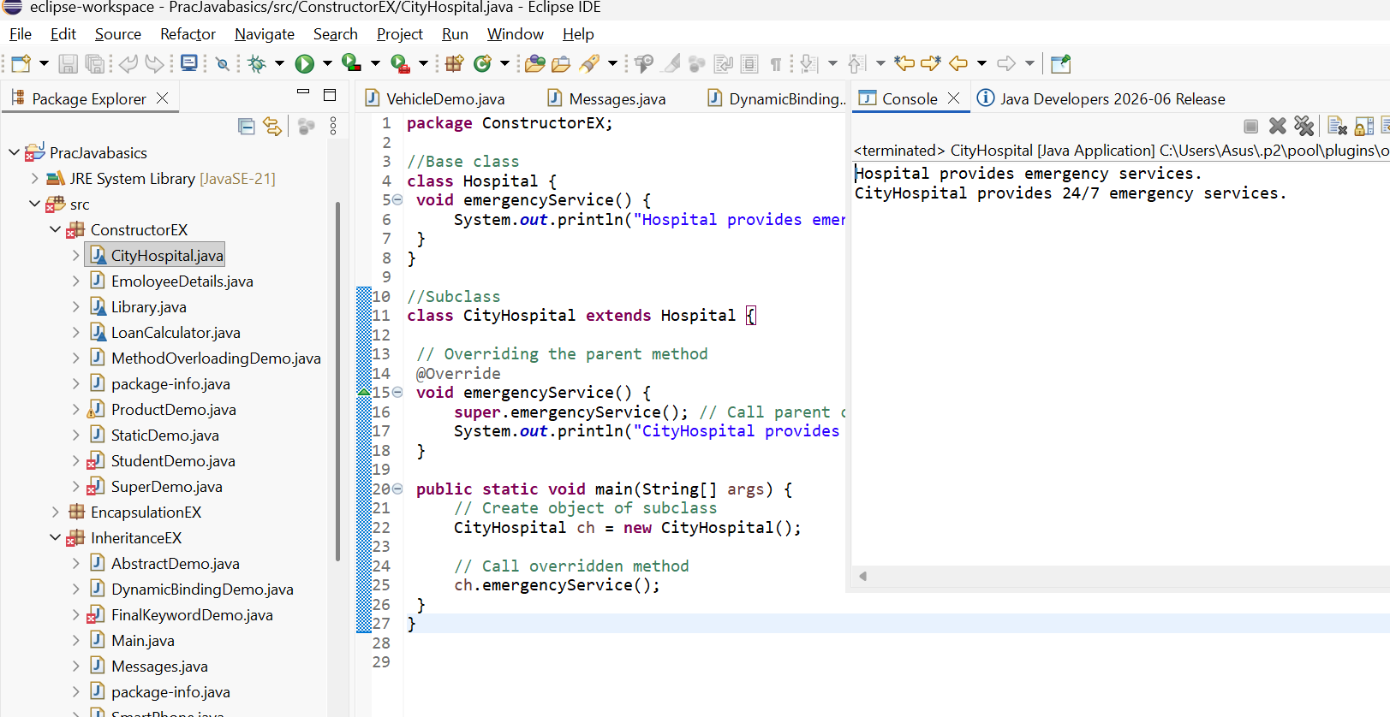
Output:
Hospital provides emergency services.
CityHospital provides 24/7 emergency services.

17. Abstract Class + Real Usage
Create an abstract class Employee with:
abstract method: calculateSalary()
concrete method: employeeDetails()
Subclass FullTimeEmployee and PartTimeEmployee implementing salary calculation logic differently.
Program:
package InheritanceEX;
abstract class Employee {
abstract void calculateSalary();
void employeeDetails() {
System.out.println("Employee details are displayed.");
}
}class FullTimeEmployee extends Employee {
void calculateSalary() {
int monthlySalary = 50000;
System.out.println("Full-Time Employee Salary: ₹" + monthlySalary);
}
}
class PartTimeEmployee extends Employee {

void calculateSalary() {
int hoursWorked = 5;
int ratePerHour = 500;
int salary = hoursWorked * ratePerHour;

System.out.println("Part-Time Employee Salary: ₹" + salary);
}
}
public class EmployeeDemo {
public static void main(String[] args) {

FullTimeEmployee ft = new FullTimeEmployee();
ft.employeeDetails();
ft.calculateSalary();

System.out.println();

PartTimeEmployee pt = new PartTimeEmployee();
pt.employeeDetails();
pt.calculateSalary();
}
}
Screenshot:
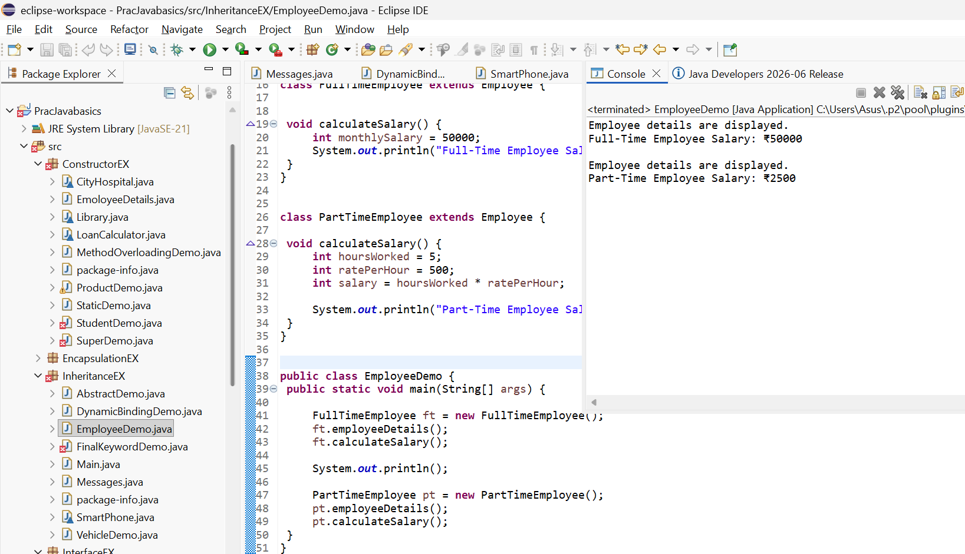
Output:
Employee details are displayed.
Full-Time Employee Salary: ₹50000

Employee details are displayed.
Part-Time Employee Salary: ₹2500

18. Interface with Multiple Implementations
Create an interface Transport with method booking().
Implement it in Bus and Flight classes.
Call using interface reference.
Program:
interface Transport {
void booking();
}
class Bus implements Transport {

public void booking() {
System.out.println("Bus ticket booked successfully.");
}
}

class Flight implements Transport {

public void booking() {
System.out.println("Flight ticket booked successfully.");
}
}

public class TransportDemo {
public static void main(String[] args) {

Transport t1 = new Bus();
t1.booking();
Transport t2 = new Flight();
t2.booking();
}
}

Screenshot:
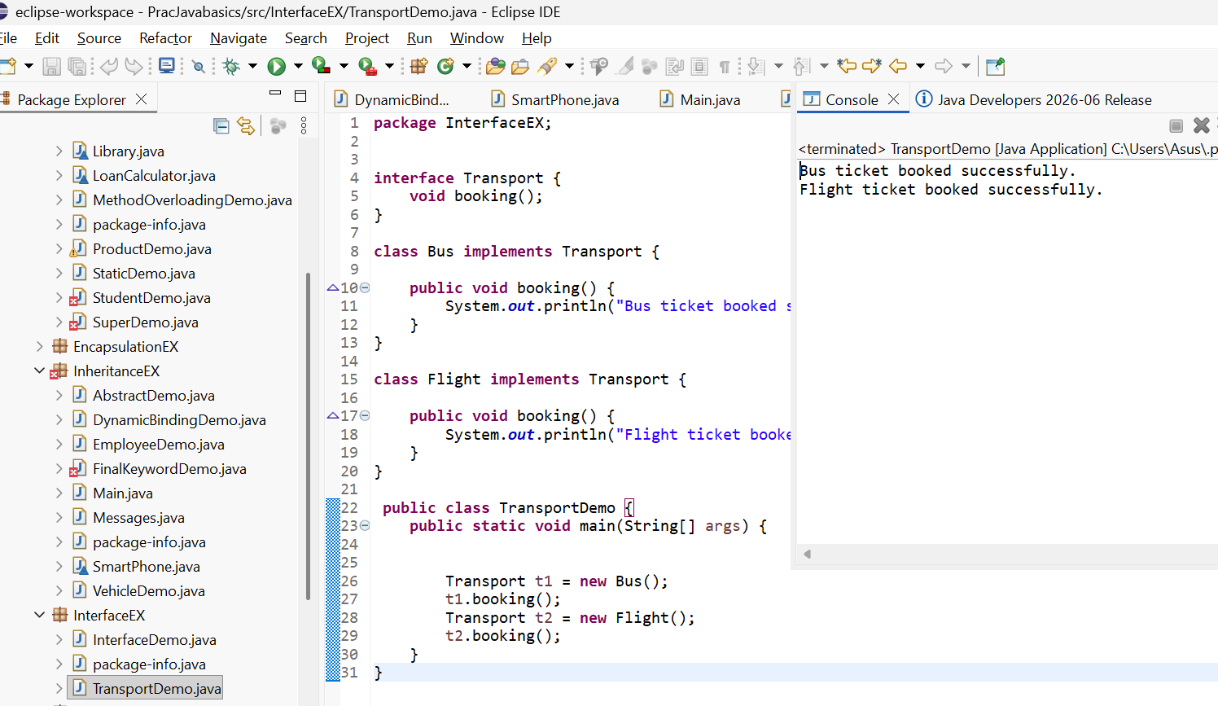
Output:
Bus ticket booked successfully.
Flight ticket booked successfully.

19. Polymorphism (Runtime + Upcasting)
Create a class Camera with a method capture().
Create a subclass DSLCamera that overrides the method.
Use parent reference to call child object method (dynamic polymorphism).

Program:
package InterfaceEX;

class Camera {
void capture() {
System.out.println("Capturing photo using Camera.");
}
}

class DSLCamera extends Camera {

void capture() {
System.out.println("Capturing high-quality photo using DSLR Camera.");
}
}

public class CameraaDemo {
public static void main(String[] args) {

Camera cam = new DSLCamera();
cam.capture(); }}
Screenshot:
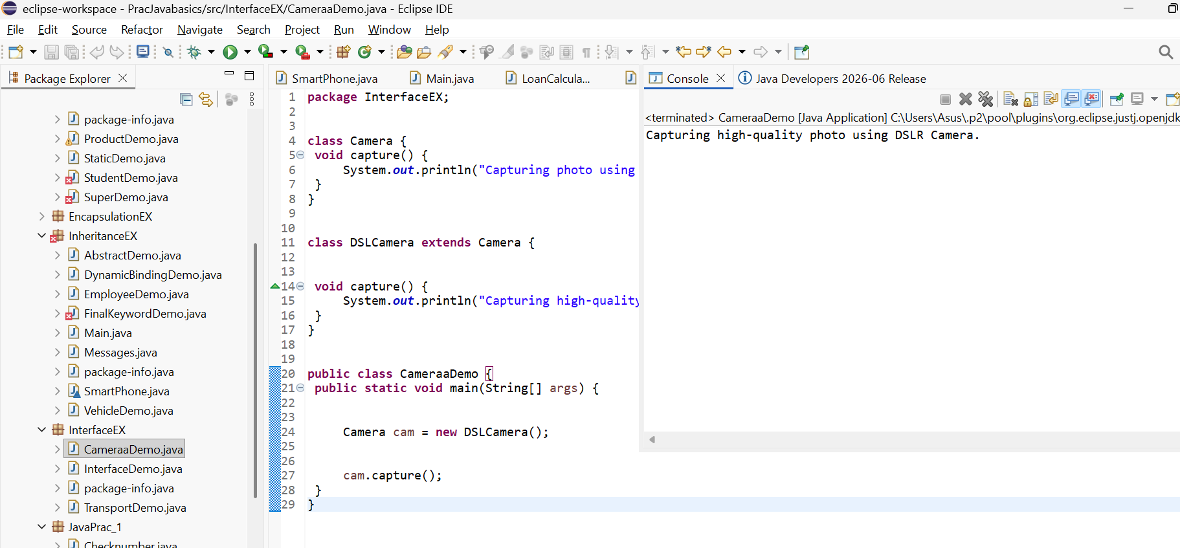
Output:
Capturing high-quality photo using DSLR Camera.

21. Static Concepts
Create a class University with: static variable country = "India" instance variable universityName. Print values using different objects to show static effect.
Program:
package ConstructorEX;
class University {
static String country = "India";
String universityName;
University(String universityName) {
this.universityName = universityName;
}
void display() {
System.out.println("University Name: " + universityName);
System.out.println("Country: " + country);
}

public static void main(String[] args) {

University u1 = new University("Delhi University");
University u2 = new University("Mumbai University");
u1.display();
System.out.println();

u2.display();
}}
Screenshot:
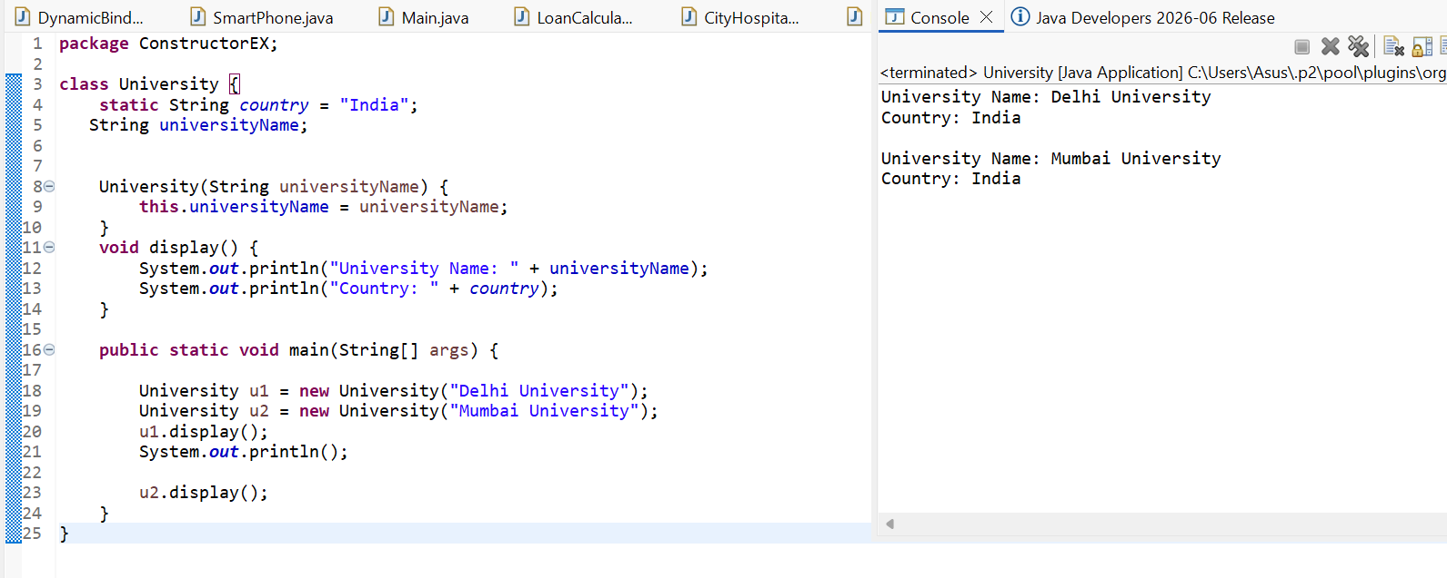
Output:
University Name: Delhi University
Country: India
University Name: Mumbai University
Country: India

22. Final Keyword + Constant
Create a class GovernmentRules with a final variable MAX_WORKING_HOURS = 8
Try modifying it inside main and observe compile-time restriction.
Program:
class GovernmentRules {
final int MAX_WORKING_HOURS = 8;
public static void main(String[] args) {
GovernmentRules rule = new GovernmentRules();
System.out.println("Maximum Working Hours: " + rule.MAX_WORKING_HOURS);
}
}

Output: Maximum Working Hours: 8

class GovernmentRules {
final int MAX_WORKING_HOURS = 8;
public static void main(String[] args) {
GovernmentRules rule = new GovernmentRules();
System.out.println("Maximum Working Hours: " + rule.MAX_WORKING_HOURS);
rule.MAX_WORKING_HOURS = 10; // Compile-time Error
}
}
Output: Screenshot
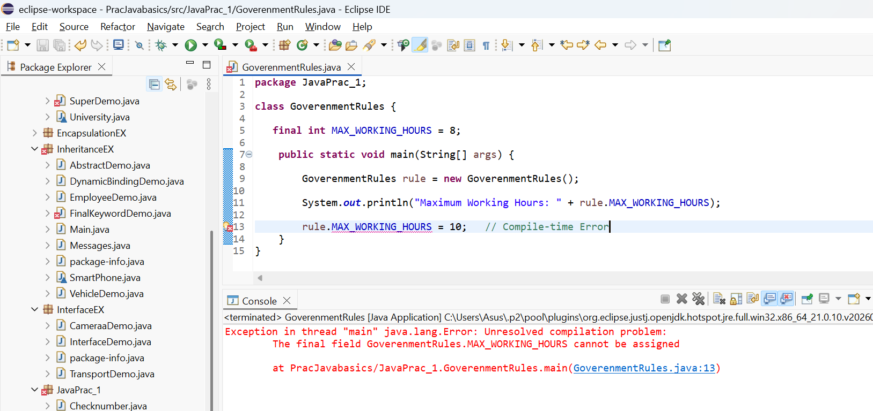

23. Constructor Chaining
Create a class Mall with:
Default constructor printing "Welcome to the Mall"
Parameterized constructor calling default constructor using this() Demonstrate constructor chaining in main.
Program:
class Mall {
Mall() {
System.out.println("Welcome to the Mall");
} Mall(String mallName) {
this(); // Calls the default constructor
System.out.println("Mall Name: " + mallName);
}
public static void main(String[] args) {
Mall m = new Mall("City Center Mall");
}
}
Screenshot: 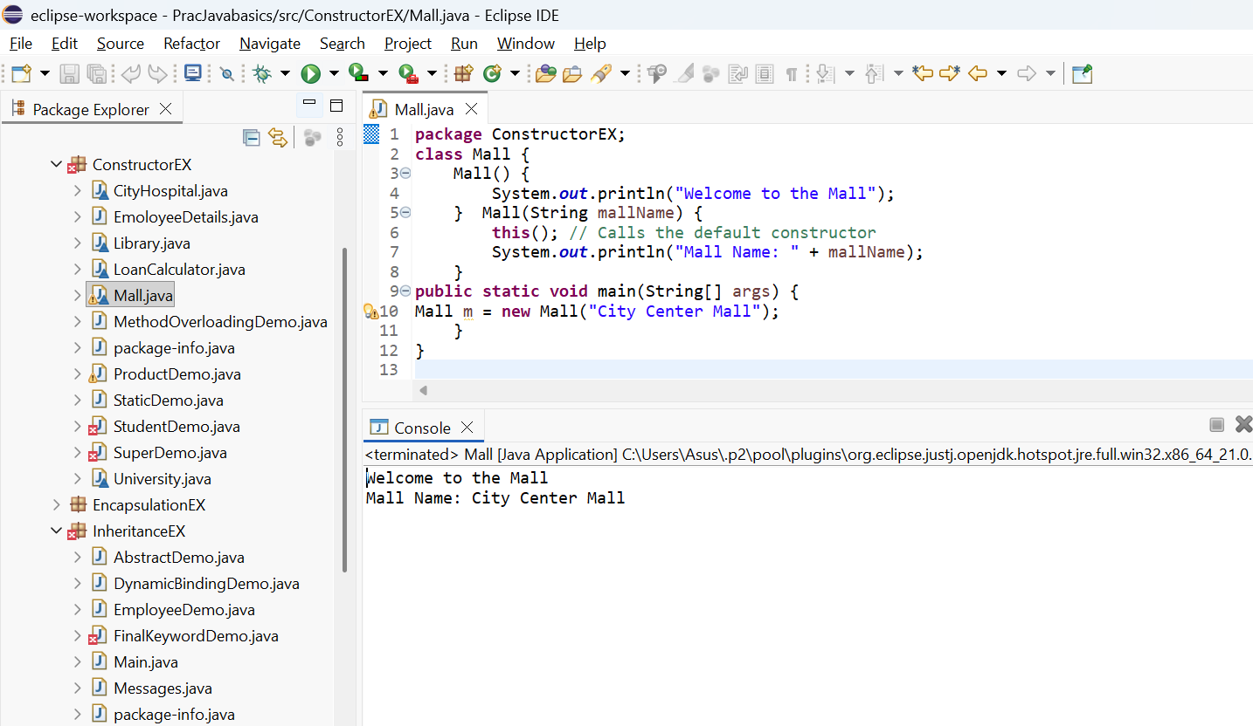
Output:
Welcome to the Mall
Mall Name: City Center Mall
Execution Flow
new Mall("City Center Mall")
|
v
Parameterized Constructor
|
this()
|
v
Default Constructor
|
v
Print: Welcome to the Mall
|
v
Return to Parameterized Constructor
|
v
Print: Mall Name: City Center Mall

24. WAP in Java
Create a Class named Shape with length as instance variable , create three methods as square , rectangle , circle
and find out their respective areas
Create a object in main method and call these different methods with the instance of object
Program:
class Shape {
double length;
void square(double side) {
double area = side * side;
System.out.println("Area of Square = " + area);
} void rectangle(double length, double breadth) {
double area = length * breadth;
System.out.println("Area of Rectangle = " + area);
} void circle(double radius) {
double area = 3.14 * radius * radius;
System.out.println("Area of Circle = " + area);
}
public static void main(String[] args) {

Shape s = new Shape();

s.square(5);
s.rectangle(10, 5);
s.circle(7);
}
}

Screenshot:
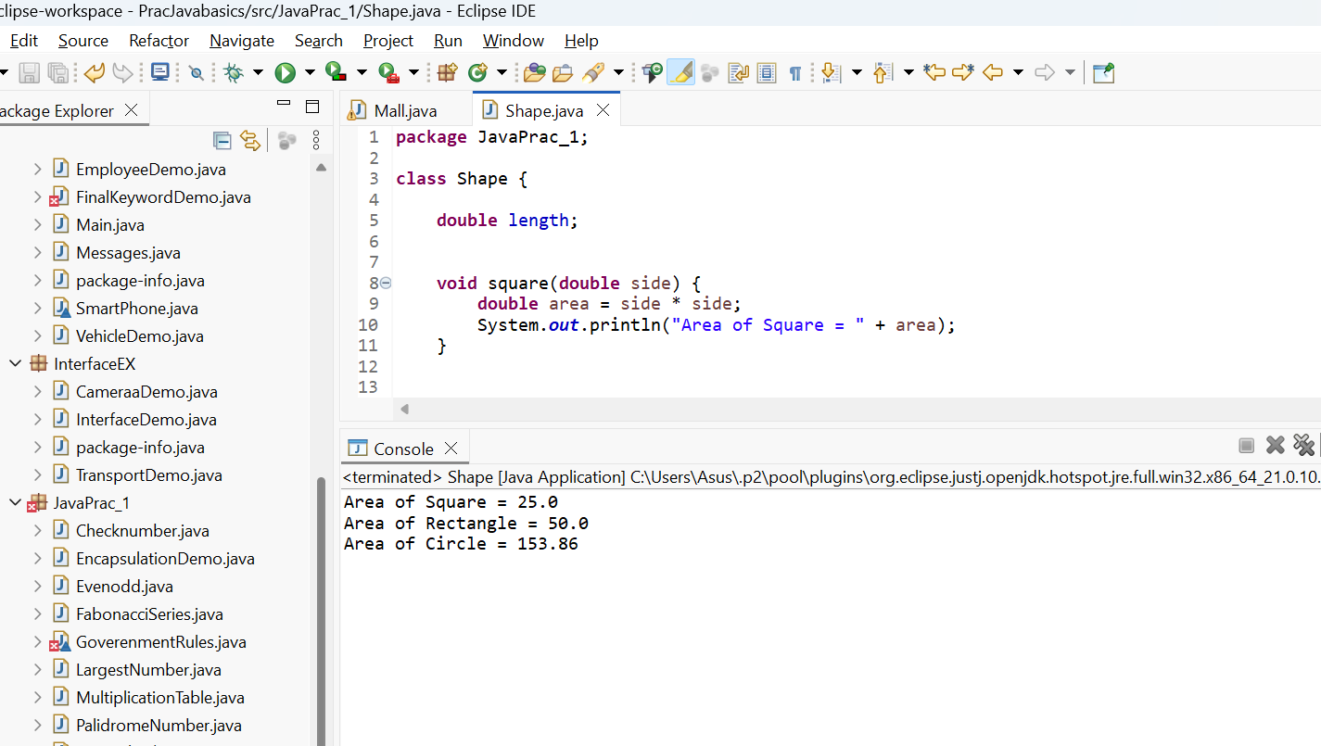
Output:
Area of Square = 25.0
Area of Rectangle = 50.0
Area of Circle = 153.86

25. WAP in Java
Create a class named school, create name as their instance variables. Create a default constructor of this class which will have a print statement to display the name of school Create a method inside the class which will display a message as "This School is based out of Kolkata". Create an object under main method and call the constructor and the method
Program:
package JavaPrac_1;
class School {

String name = "St. Xavier's School";

School() {
System.out.println("School Name: " + name);
}

void showLocation() {
System.out.println("This School is based out of Kolkata");
}

public static void main(String[] args) {

School s = new School();

s.showLocation();
}
}

Screenshot:
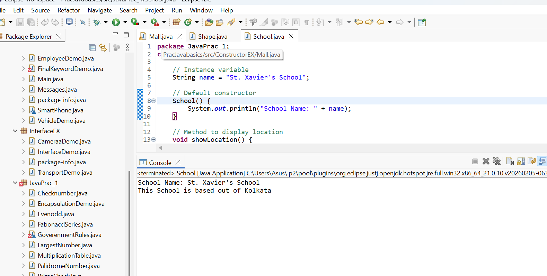

Output:
School Name: St. Xavier's School
This School is based out of Kolkata

26. WAP in Java to create a class named school create name, address, strength as their instance variables. Create two constructor one with two variables and one with all the three variables. Create a method that will display all the three parameters. Create two object of this class and call the respective methods
Program:
class School {
String name;
String address;
int strength;
School(String name, String address) {
this.name = name;
this.address = address;
this.strength = 0;
}
School(String name, String address, int strength) {
this.name = name;
this.address = address;
this.strength = strength;
}
void display() {
System.out.println("School Name : " + name);
System.out.println("Address : " + address);
System.out.println("Strength : " + strength);
System.out.println();
}public static void main(String[] args) {
School s1 = new School("Delhi Public School", "Delhi");
School s2 = new School("St. Xavier's School", "Kolkata", 2500);
s1.display();
s2.display();}}
Screenshot:
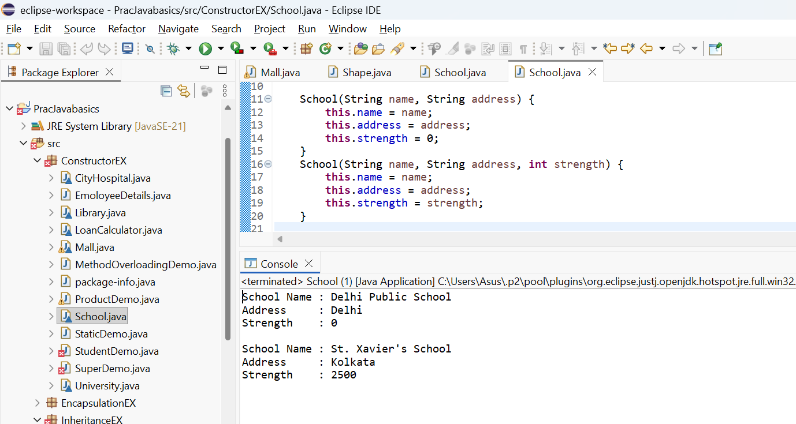

Output:
School Name : Delhi Public School
Address : Delhi
Strength : 0

School Name : St. Xavier's School
Address : Kolkata
Strength : 2500

